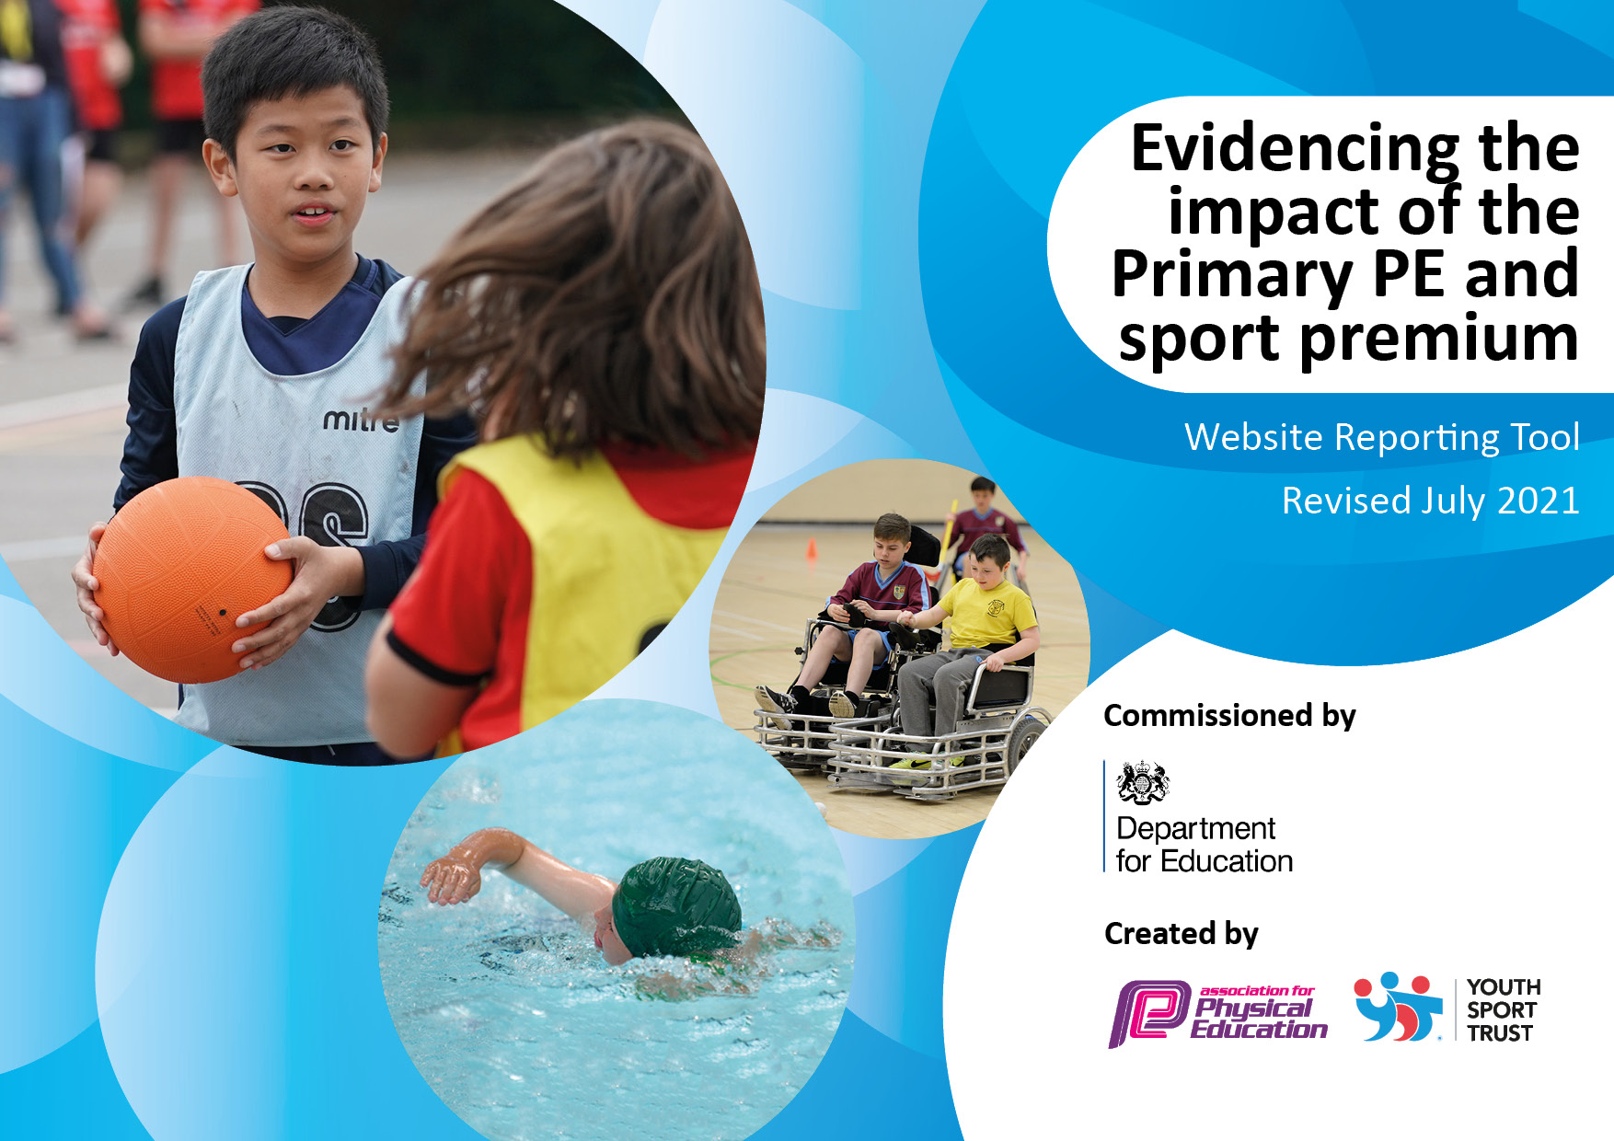

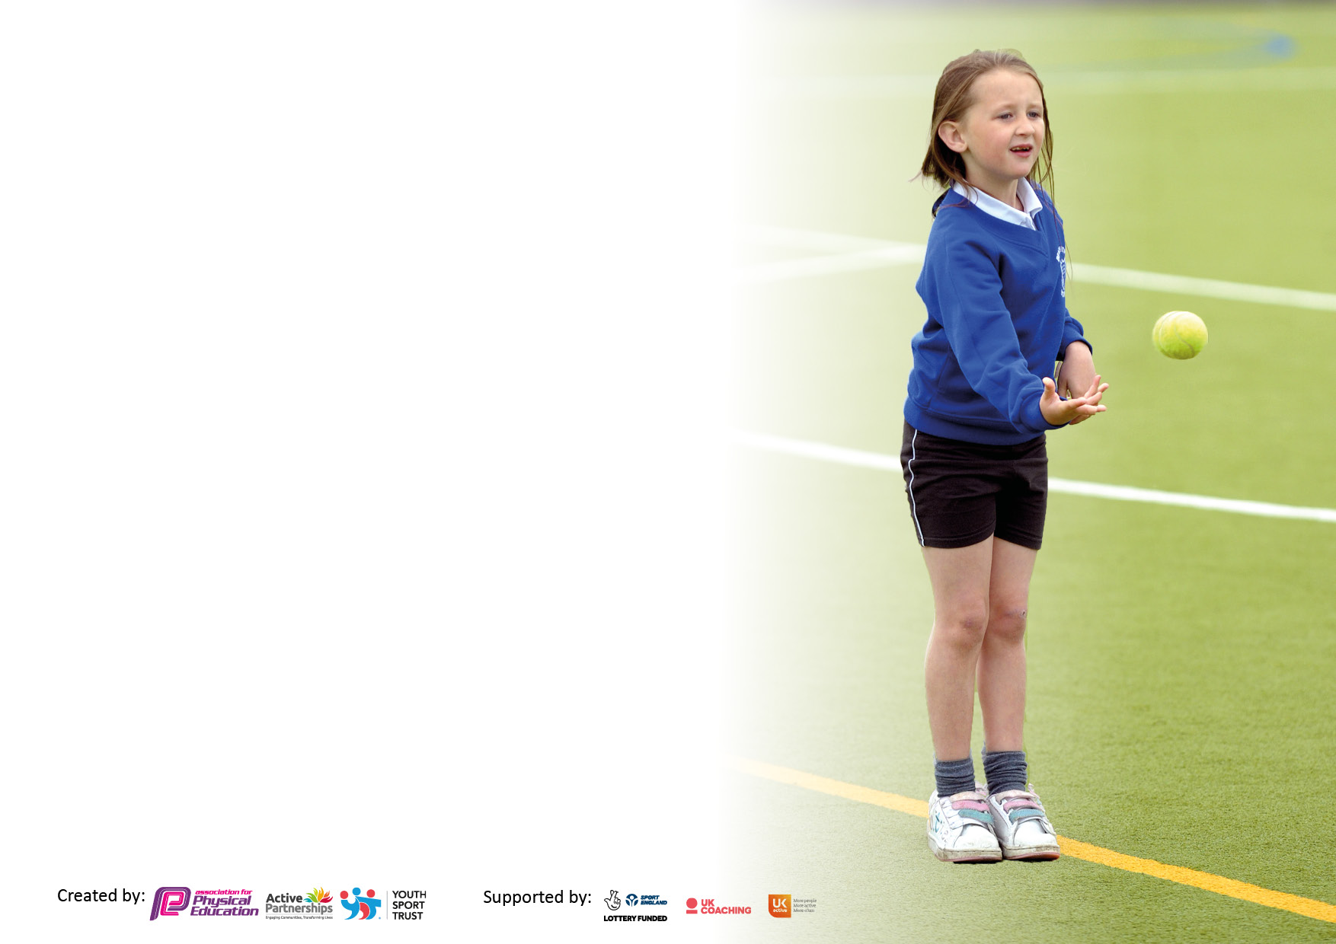

It is important that your grant is used effectively and based on school need. The Education Inspection Framework makes clear there will be a focus on **‘whether leaders and those responsible for governors all understand their respective roles and perform these in a way that enhances the effectiveness of the school’**.

Under the Quality of Education Ofsted inspectors consider:

**Intent** - Curriculum design, coverage and appropriateness

**Implementation** - Curriculum delivery, Teaching (pedagogy) and Assessment

**Impact** - Attainment and progress

To assist schools with common transferable language this template has been developed to utilise the same three headings which should make your plans easily transferable between working documents.

Schools must use the funding to make **additional and sustainable** improvements to the quality of Physical Education, School Sport and Physical Activity (PESSPA) they offer. This means that you should use the Primary PE and sport premium to:

* Develop or add to the PESSPA activities that your school already offer
* Build capacity and capability within the school to ensure that improvements made now will benefit pupils joining the school in future years
* The Primary PE and sport premium should not be used to fund capital spend projects; the school’s budget should fund these.

Pleasevisitgov.ukfortherevisedDfEguidanceincludingthe5keyindicatorsacrosswhichschoolsshoulddemonstrate animprovement.Thisdocumentwillhelpyoutoreviewyourprovisionandtoreportyourspend.DfEencouragesschools to use this template as an effective way of meeting the reporting requirements of the Primary PE and sport premium.

We recommend you start by reflecting on the impact of current provision and reviewing the previous spend.

Schools are required to publish details of how they spend this funding, including any under-spend from 2019/2020, as well as on the impact it has on pupils’ PE and sport participation and attainment. **All funding must be spent by 31st July 2022.**

We recommend regularly updating the table and publishing it on your website throughout the year. This evidences your ongoing self-evaluation of how you are using the funding to secure maximum, sustainable impact. Final copy must be posted on your website by the end of the academic year and no later than the 31st July 2021. To see an example of how to complete the table please click HERE.

Created by: Supported by:

**Details with regard to funding**

Please complete the table below.

|  |  |
| --- | --- |
| Total amount carried over from 2022/23 | £0 |
| Total amount allocated for 2023/24 | £17, 675 |
| How much (if any) do you intend to carry over from this total fund into 2024/25 | £1025 Contingency |
| Total amount allocated for 2023/24 | £17, 675 |
| Total amount of funding for 2023/24. To be spent and reported on by 31st July 2023. | £17, 675 |

**Swimming Data**

Please report on your Swimming Data below.

|  |  |
| --- | --- |
| Meeting national curriculum requirements for swimming and water safety.  N.B. Complete this section to your best ability. For example you might have practised safe self-rescue techniques on dry land which you can then transfer to the pool when school swimming restarts.  **Due to exceptional circumstances priority should be given to ensuring that pupils can perform safe self rescue even if they do not fully meet the first two requirements of the NC programme of study** |  |
| What percentage of your current Year 6 cohort swim competently, confidently and proficiently over a distance of at least 25 metres?  **N.B.** Even though your pupils may swim in another year please report on their attainment on leaving primary school at the end of the summer term 2023.  Please see note above | 90.3% |
| What percentage of your current Year 6 cohort use a range of strokes effectively [for example, front crawl, backstroke and breaststroke]?  Please see note above | 77.5% |
| **What percentage of your current Year 6 cohort perform safe self-rescue in different water-based situations?** | 100% |
| Schools can choose to use the Primary PE and sport premium to provide additional provision for swimming but this must be for activity **over and above** the national curriculum requirements. Have you used it in this way? | Yes |

**Action Plan and Budget Tracking**

Capture your intended annual spend against the 5 key indicators. Clarify the success criteria and evidence of impact that you intend to measure to evaluate for pupils today and for the future.

|  |  |  |  |  |
| --- | --- | --- | --- | --- |
| **Academic Year:** 2023/24 | **Total fund allocated:** | **Date Updated:** | |  |
| **Key indicator 1:** The engagement of all pupils in regular physical activity – Chief Medical Officers guidelines recommend that primary school pupils undertake at least 30 minutes of physical activity a day in school | | | | Percentage of total allocation: |
| 22.7% |
| **Intent** | **Implementation** | | **Impact** |  |
| Your school focus should be clear what you want the pupils to know and be able to do and about  what they need to learn and to  consolidate through practice: | Make sure your actions to achieve are linked to your intentions: | Funding allocated: | Evidence of impact: what do pupils now know and what can they now do? What has changed?: | Sustainability and suggested next steps: |
| 1. Educate children in the value and benefits of a healthy active lifestyle and increase pupils’ activity levels throughout the day. 2. Develop sports ambassadors and play leaders to support active playtimes and support extra-curricular activities 3. Increase the number of extracurricular sports clubs available to children. 4. Engage parents to support at home physical activity. | 1. Through PE lessons, sports, 3x weekly yoga sessions, daily mile track and outdoor learning days, ensure the children understand the role of movement in the development of their own physicality, fitness and well-being. Timetabled PE lessons taught by a specialist teacher. 2. Purchase new playground equipment and train up sports ambassadors and play leaders in a variety of games to engage the children with. 3. Before school Cross Country Club. Targeted breakfast club. Lunchtime football club x 3 Lunchtime cross country club After-school Football, Dance, and Judo clubs. 4. Promotion of Active Families on the school website, which provides a wealth of balls skills, fundamental skills, and fitness games and activities that, can be done at home. Colour run. | £4000 | 1. Positive attitudes to health and well-being and an increase in pupil concentration, self-esteem and behaviour. Children taking part in daily additional activities such as yoga or the daily mile. 2. Sports ambassadors and play leaders support active play during lunch times. 3. Autumn Term ‘22 Extra-Curricular Club Attendance: Year 1: 55% Year 2: 54% Year 3: 100% Year 4: 50% Year 5: 62% Year 6: 55% |  |
| **Key indicator 2:** The profile of PESSPA being raised across the school as a tool for whole school improvement | | | | Percentage of total allocation: |
| 23.5% |
| **Intent** | **Implementation** | | **Impact** |  |
| Your school focus should be clear what you want the pupils to know and be able to do and about  what they need to learn and to  consolidate through practice: | Make sure your actions to achieve are linked to your intentions: | Funding allocated: | Evidence of impact: what do pupils now know and what can they now do? What has changed?: | Sustainability and suggested next steps: |
| 1. Using PE and sport to enable the development of life skills that are transferred to other curriculum areas, wider school and beyond 2. Ensure PE and school sport is visible in the school (assemblies, school website, pictures) 3. High quality PE lessons | 1. Contribute funding to Bracknell Forest School Sport Partnership which provides the following opportunities:  * Competitions and events * Opportunities for CPD  1. Weekly celebration assemblies to give recognition to both inside and outside of school sports achievements. PE and sports page on the website. Twitter feed mentioning sports events and achievements. 2. Employment of sports coach. Purchasing a high quality PE curriculum. | £4150 | 1 and 2. PE and sport have a high profile in the school and are celebrated across the life of the school.  3. Pupil voice informs us that pupils enjoy PE lessons and the variety of activities that are on offer through our PE curriculum. |  |

|  |  |  |  |  |
| --- | --- | --- | --- | --- |
| **Key indicator 3:** Increased confidence, knowledge and skills of all staff in teaching PE and sport | | | | Percentage of total allocation: |
| 17% |
| **Intent** | **Implementation** | | **Impact** |  |
| Your school focus should be clear | Make sure your actions to | Funding | Evidence of impact: what do | Sustainability and suggested |
| what you want the pupils to know | achieve are linked to your | allocated: | pupils now know and what | next steps: |
| and be able to do and about | intentions: |  | can they now do? What has |  |
| what they need to learn and to |  |  | changed?: |  |
| consolidate through practice: |  |  |  |  |
| 1. Improve the standard of teaching and learning in PE and sport. 2. Increase confidence of all staff teaching PE | 1. Every member of teaching staff to work alongside outdoor learning leader for a whole morning; session modelled for staff, opportunities to team-teach and coach. Purchase of GetSet4PE scheme of work. Learning walks and staff voice. 2. Questionnaire to monitor pupil and staff attitudes towards PE | £3000 | 1. Pupils are beginning to use specific vocabulary related to their block of learning. Children are engaged and enjoy PE lessons and know how to move their learning forward. 2. Majority of teachers are confident in their teaching of PE especially with guidance from GetSet4PE. |  |
| **Key indicator 4:** Broader experience of a range of sports and activities offered to all pupils | | | | Percentage of total allocation: |
| 15.6% |
| **Intent** | **Implementation** | | **Impact** |  |
| Your school focus should be clear | Make sure your actions to | Funding | Evidence of impact: what do | Sustainability and suggested |
| what you want the pupils to know | achieve are linked to your | allocated: | pupils now know and what | next steps: |
| and be able to do and about | intentions: |  | can they now do? What has |  |
| what they need to learn and to |  |  | changed?: |  |
| consolidate through practice: |  |  |  |  |
| 1. Provide opportunities to take part in a diverse range of school sport through extra-curricular clubs, competitions and events. 2. Continue to offer additional extracurricular opportunities for all pupils to take part in physical activity and sport - Providing additional links to- - Community Sports Clubs - Children participate in festivals/tournaments held through PSP. 3. Increase opportunities for KS1 children | 1. and 2. New before and after school clubs implemented (Judo, Cross Country, Badminton, Street Dance, Football). Wide range of sports events and competitions entered through our partnership with Bracknell Forest.   3 Summer term sports clubs to be opened up to KS1 children. | £2750 | 1. Children now have knowledge of a wide range of sports and how to play them. 2. Autumn Term ‘22 Extra-Curricular Club Attendance   Year 1: 55% Year 2: 54% Year 3: 100% Year 4: 50% Year 5: 62% Year 6: 55% |  |

|  |  |  |  |  |
| --- | --- | --- | --- | --- |
| **Key indicator 5:** Increased participation in competitive sport | | | | Percentage of total allocation: |
| 15.6% |
| **Intent** | **Implementation** | | **Impact** |  |
| Your school focus should be clear | Make sure your actions to | Funding | Evidence of impact: what do | Sustainability and suggested |
| what you want the pupils to know | achieve are linked to your | allocated: | pupils now know and what | next steps: |
| and be able to do and about | intentions: |  | can they now do? What has |  |
| what they need to learn and to |  |  | changed?: |  |
| consolidate through practice: |  |  |  |  |
| 1. Provide opportunities for all children to challenge themselves through both intra and inter school sport where the children's motivation, competence and confidence are at the centre of the competition and the focus is on the process rather than the outcome. 2. Increased participation in School Games competitions. 3. Providing opportunities for children with SEND, the least active and the least confident to attend competitions and events. | 1. and 2. Participation in all BF community events and festivals. Participation in the Berkshire FA Football Cup. Participation in the Thames Valley Running League. Targeted pupil selection for the BF community events and festivals. Friendly football and netball matches, plus multi-skills events to be arranged.   3 Events such as Boccia for SEND children. Select children who we feel would benefit most from the opportunities available in the Bracknell Forest events calendar. | £2750 | 1 and 2  Since September 2022  Year 3: 68% Year 4: 40% Year 5: 58% Year 6: 74% (100% including Bouldering)  3  SEN = 21 children/10 (48%) attended a club/17 81%) represented school |  |

|  |  |
| --- | --- |
| Signed off by | |
| Head Teacher: | Simon Cotterill |
| Date: | September 2023 |
| Subject Leader: | Charlotte Farrelly/Wayne Boardman |
| Date: | September 23 |
| Governor: | Chris Jackson |
| Date: | September 23 |